Welcome to
Trinity Lutheran Church
Lutheran Church—Missouri Synod
A Stephen Ministry Congregation

1354 South Otsego Avenue
Gaylord, Michigan 49735
Church Phone: (989) 732-4816

Church Email: secretary@trinitygaylord.com
www.trinitygaylord.com

Office Hours: Monday through Friday 9am – 1pm

OUR PURPOSE
…is to LOVE GOD, LOVE OTHERS, AND SERVE THE WORLD by worshiping the Lord Jesus, bringing our members into Christ-like maturity, and equipping them through Word and Sacrament for their mission and ministry. We go heart to heart into the world with Jesus, sharing His love, caring for one another, praying, and bringing the lost into a relationship with Christ, by the working of the Holy Spirit.

April 24, 2022
Second Sunday of Easter
Preacher: Rev. Ken Bernthal

ABOUT OUR WORSHIP
We welcome all who gather here today! We are blessed to celebrate together the mercy, grace, and love we have from God through the death and resurrection of our Lord Jesus Christ.

Children: Families with children are very welcome here. Having children in church is important so they can begin to learn about their faith in Jesus, and it’s good for the whole congregation to see. Please feel comfortable keeping “squirmy” kids in the service. This is where they belong, too!

Pew Cards: Guests and Members, please fill out the Guest/Member card located on the back of the pew in front of you and pass it to the end of the aisle. If you forget you can put it in the offering plate on your way out.

If standing is difficult: Please feel free to remain seated during any portion of the service. Please let an Elder or Usher know if you need communion in your pew seat.

About our celebration of Holy Communion: We celebrate the Lord’s Supper in the confession and glad confidence that, as he says, our Lord gives into our mouths not only bread and wine but his very body and blood to eat and to drink for the forgiveness of sins and to strengthen our union with him and with one another. Our Lord invites to his table those who trust his words, repent of all sin, and set aside any refusal to forgive and love as he forgives and loves us, that they may show forth his death until he comes.

Because those who eat and drink our Lord’s body and blood contrary to that which is stated above do so to their great harm, and also because Holy Communion is a confession of the faith which is confessed at this altar. Anyone who is not yet instructed, in doubt, or who hold a confession differing from that of the Lutheran Church—Missouri Synod, and yet desire to receive the sacrament, are asked first to speak with Pastor. Those not communing are still invited to come forward for a blessing from Pastor, and you may indicate this by crossing your arms over your chest.
TTTTTT

GREETING

P Peace be with you.
C And also with you.
T ORDER OF SERVICE T
(The liturgy is from Divine Service Setting four LSB pg. 203ff)

OPENING HYMN
Praise to the Lord, the Almighty LSB 790
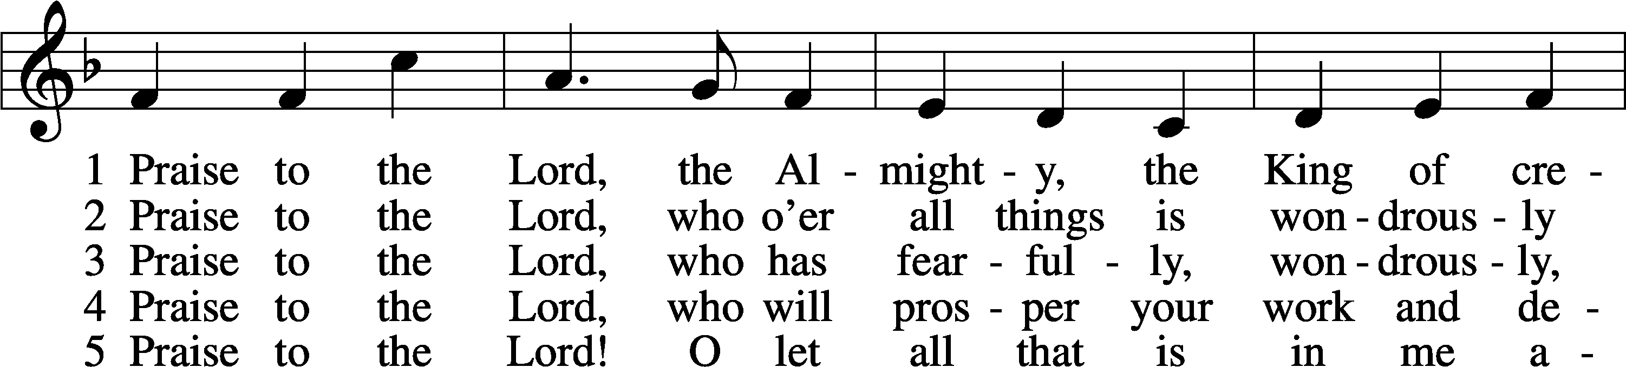
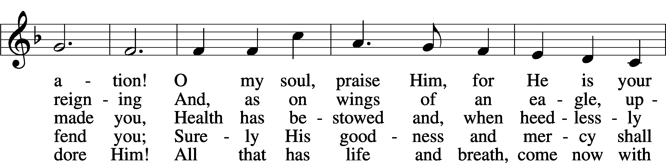
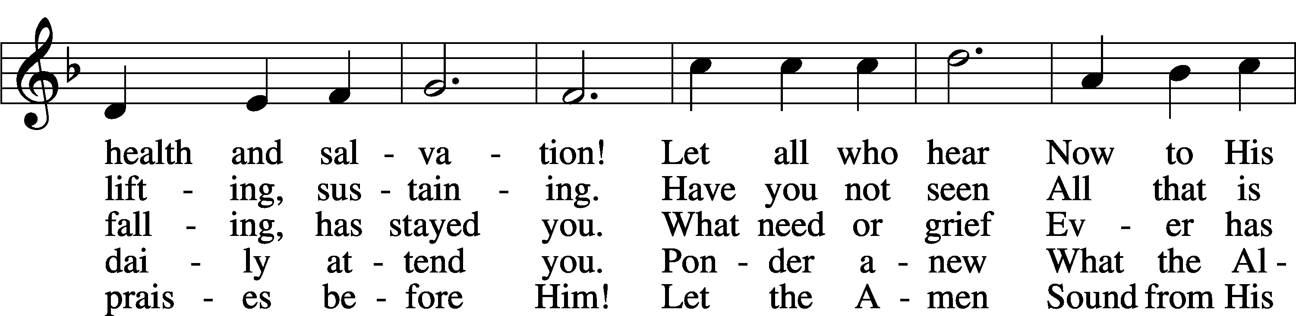
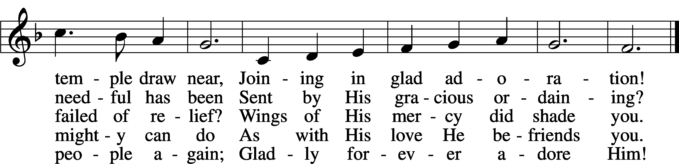
Text: Joachim Neander, 1650–80; tr. Catherine Winkworth, 1827–78, alt.
Tune: Ander Theil Des Erneuerten Gesang-Buchs, 1665, Stralsund
Text and tune: Public domain

Please stand as able
CONFESSION and ABSOLUTION
The sign of the cross may be made by all in remembrance of their Baptism.

P In the name of the Father and of the T Son and of the Holy Spirit.
C Amen.
P Our help is in the name of the Lord,
C who made heaven and earth.
P If You, O Lord, kept a record of sins, O Lord, who could stand?
C But with You there is forgiveness; therefore, You are feared.
P Since we are gathered to hear God’s Word, call upon Him in prayer and praise, and receive the body and blood of our Lord Jesus Christ in the fellowship of this altar, let us first consider our unworthiness and confess before God and one another that we have sinned in thought, word, and deed, and that we cannot free ourselves from our sinful condition. Together as His people let us take refuge in the infinite mercy of God, our heavenly Father, seeking His grace for the sake of Christ, and saying: God, be merciful to me, a sinner.
C Almighty God, have mercy upon us, forgive us our sins, and lead us to everlasting life. Amen.
P Almighty God, merciful Father, in Holy Baptism You declared us to be Your children and gathered us into Your one, holy Church, in which You daily and richly forgive us our sins and grant us new life through Your Spirit. Be in our midst, enliven our faith, and graciously receive our prayer and praise; through Your Son, Jesus Christ, our Lord.
C Amen.

SERVICE OF THE WORD
INTROIT Psalm 105:1–5, 8; antiphon: 1 Peter 2:2–3
P Like newborn infants, long for the pure spiritual milk, that by it you may grow up to salvation—
if indeed you have tasted that the Lord is good.
C Oh give thanks to the Lord; call upon his name;
make known his deeds among the peoples!
P Sing to him, sing praises to him;
tell of all his wondrous works!
C Glory in his holy name;
let the hearts of those who seek the Lord rejoice!

P Seek the Lord and his strength;
seek his presence continually!
C Remember the wondrous works that he has done,
his miracles, and the judgments he uttered.
P He remembers his covenant forever,
the word that he commanded, for a thousand generations.
P Glory be to the Father and to the Son
and to the Holy Spirit;
as it was in the beginning,
is now, and will be forever. Amen.
P Like newborn infants, long for the pure spiritual milk, that by it you may grow up to
salvation—
if indeed you have tasted that the Lord is good.

KYRIE LSB 204
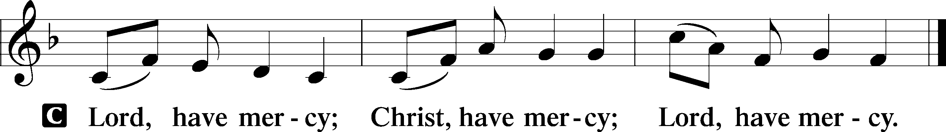

GLORIA IN EXCELSIS LSB 204
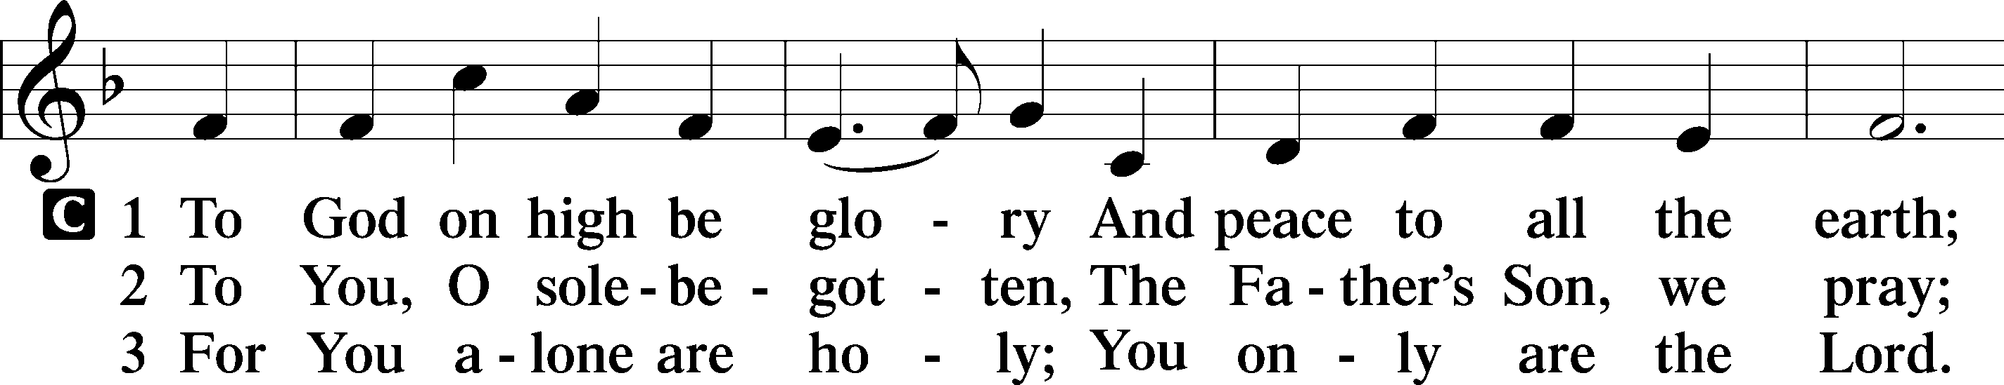
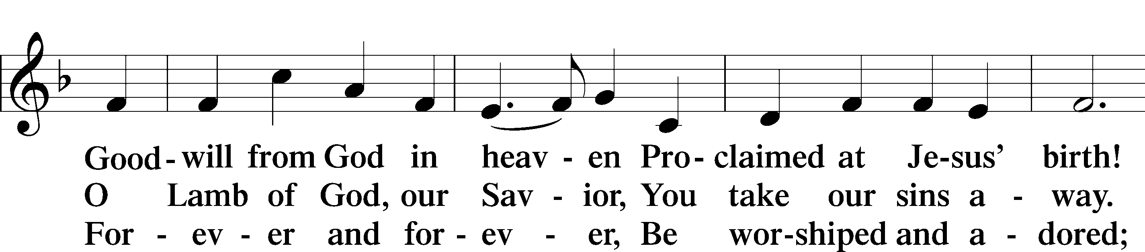
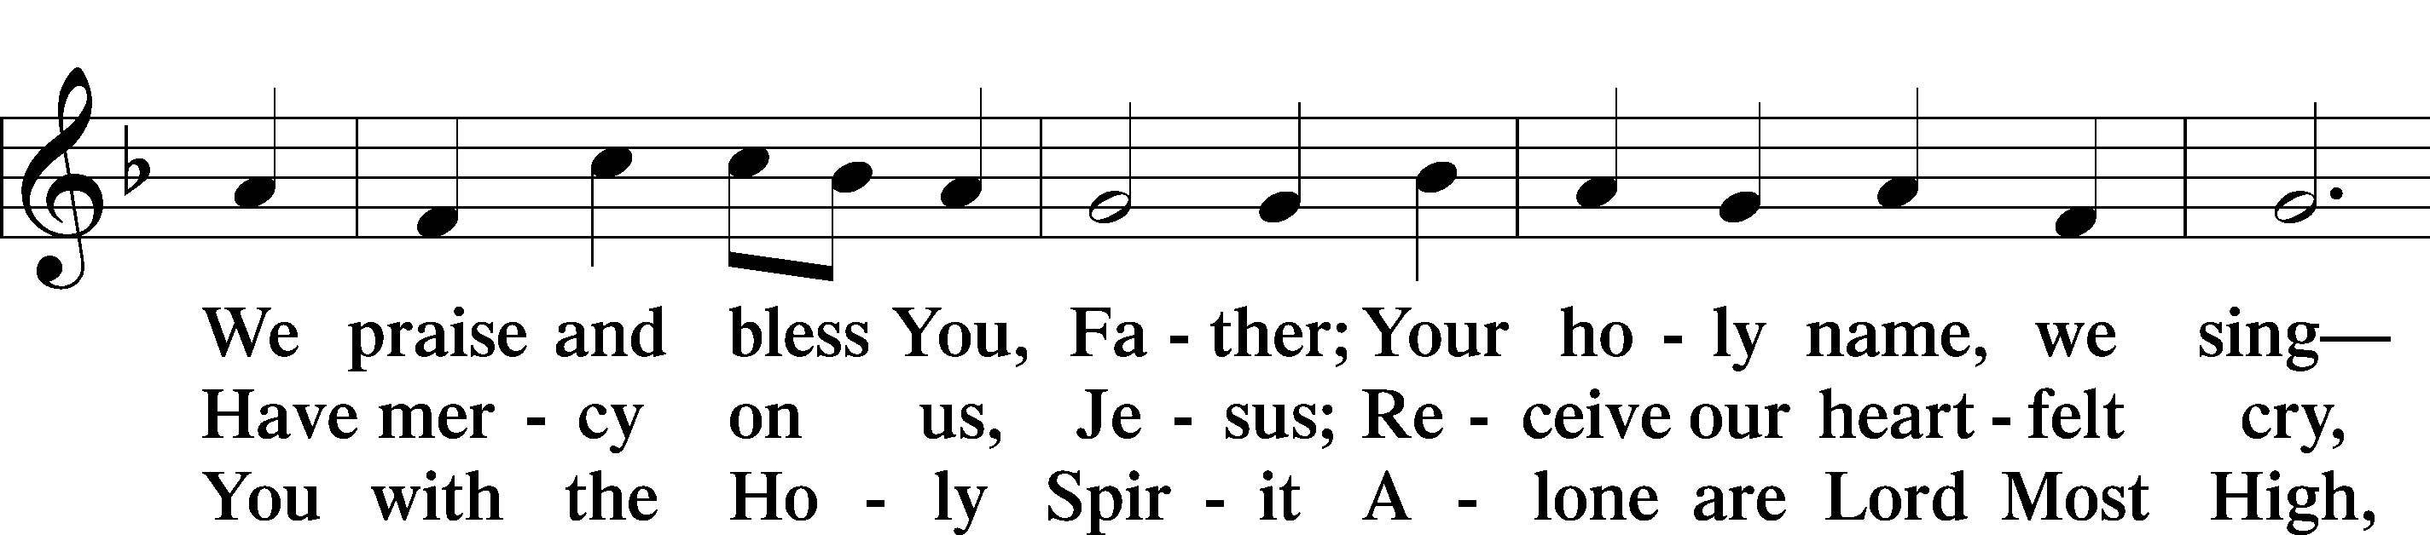
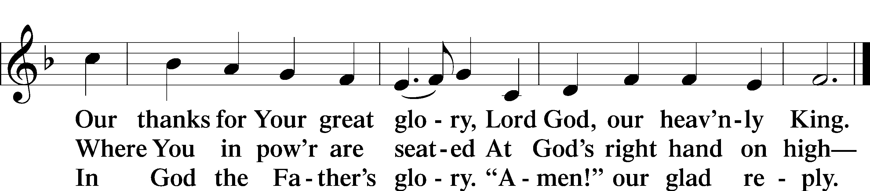
Text: Stephen P. Starke

SALUTATION AND COLLECT OF THE DAY
P The Lord be with you.
C And also with you.

P Let us pray.
Almighty God, grant that we who have celebrated the Lord’s resurrection may by Your grace confess in our life and conversation that Jesus is Lord and God; through the same Jesus Christ, Your Son, who lives and reigns with You and the Holy Spirit, one God, now and forever.
C Amen.

Please be seated

FIRST READING Acts 5:12–32
¹²Now many signs and wonders were regularly done among the people by the hands of the apostles. And they were all together in Solomon’s Portico. ¹³None of the rest dared join them, but the people held them in high esteem. ¹⁴And more than ever believers were added to the Lord, multitudes of both men and women, ¹⁵so that they even carried out the sick into the streets and laid them on cots and mats, that as Peter came by at least his shadow might fall on some of them. ¹⁶The people also gathered from the towns around Jerusalem, bringing the sick and those afflicted with unclean spirits, and they were all healed.

¹⁷But the high priest rose up, and all who were with him (that is, the party of the Sadducees), and filled with jealousy ¹⁸they arrested the apostles and put them in the public prison. ¹⁹But during the night an angel of the Lord opened the prison doors and brought them out, and said, ²⁰“Go and stand in the temple and speak to the people all the words of this Life.” ²¹And when they heard this, they entered the temple at daybreak and began to teach.
Now when the high priest came, and those who were with him, they called together the council and all the senate of Israel and sent to the prison to have them brought. ²²But when the officers came, they did not find them in the prison, so they returned and reported, ²³“We found the prison securely locked and the guards standing at the doors, but when we opened them we found no one inside.” ²⁴Now when the captain of the temple and the chief priests heard these words, they were greatly perplexed about them, wondering what this would come to. ²⁵And someone came and told them, “Look! The men whom you put in prison are standing in the temple and teaching the people.” ²⁶Then the captain with the officers went and brought them, but not by force, for they were afraid of being stoned by the people.
²⁷And when they had brought them, they set them before the council. And the high priest questioned them, ²⁸saying, “We strictly charged you not to teach in this name, yet here you have filled Jerusalem with your teaching, and you intend to bring this man’s blood upon us.” ²⁹But Peter and the apostles answered, “We must obey God rather than men. ³⁰The God of our fathers raised Jesus, whom you killed by hanging him on a tree. ³¹God exalted him at his right hand as Leader and Savior, to give repentance to Israel and forgiveness of sins. ³²And we are witnesses to these things, and so is the Holy Spirit, whom God has given to those who obey him.”

P This is the Word of the Lord.
C Thanks be to God.

EPISTLE Revelation 1:4–18
⁴John to the seven churches that are in Asia:
Grace to you and peace from him who is and who was and who is to come, and from the seven spirits who are before his throne, ⁵and from Jesus Christ the faithful witness, the firstborn of the dead, and the ruler of kings on earth.
To him who loves us and has freed us from our sins by his blood ⁶and made us a kingdom, priests to his God and Father, to him be glory and dominion forever and ever. Amen. ⁷Behold, he is coming with the clouds, and every eye will see him, even those who pierced him, and all tribes of the earth will wail on account of him. Even so. Amen.
⁸“I am the Alpha and the Omega,” says the Lord God, “who is and who was and who is to come, the Almighty.”

⁹I, John, your brother and partner in the tribulation and the kingdom and the patient endurance that are in Jesus, was on the island called Patmos on account of the word of God and the testimony of Jesus. ¹⁰I was in the Spirit on the Lord’s day, and I heard behind me a loud voice like a trumpet ¹¹saying, “Write what you see in a book and send it to the seven churches, to Ephesus and to Smyrna and to Pergamum and to Thyatira and to Sardis and to Philadelphia and to Laodicea.”
¹²Then I turned to see the voice that was speaking to me, and on turning I saw seven golden lampstands, ¹³and in the midst of the lampstands one like a son of man, clothed with a long robe and with a golden sash around his chest. ¹⁴The hairs of his head were white like wool, as white as snow. His eyes were like a flame of fire, ¹⁵his feet were like burnished bronze, refined in a furnace, and his voice was like the roar of many waters. ¹⁶In his right hand he held seven stars, from his mouth came a sharp two-edged sword, and his face was like the sun shining in full strength.
¹⁷When I saw him, I fell at his feet as though dead. But he laid his right hand on me, saying, “Fear not, I am the first and the last, ¹⁸and the living one. I died, and behold I am alive forevermore, and I have the keys of Death and Hades.

P This is the Word of the Lord.
C Thanks be to God.

Please stand as able

ALLELUIA AND VERSE LSB 205
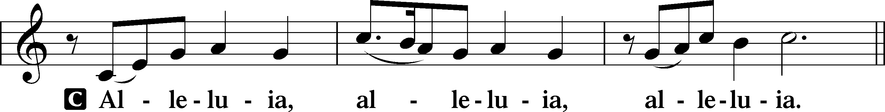

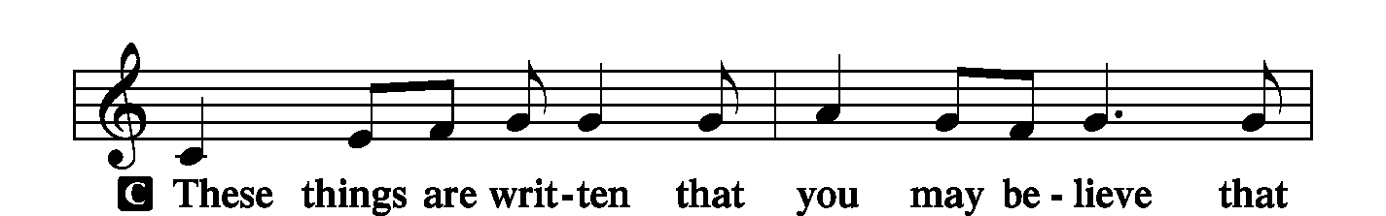
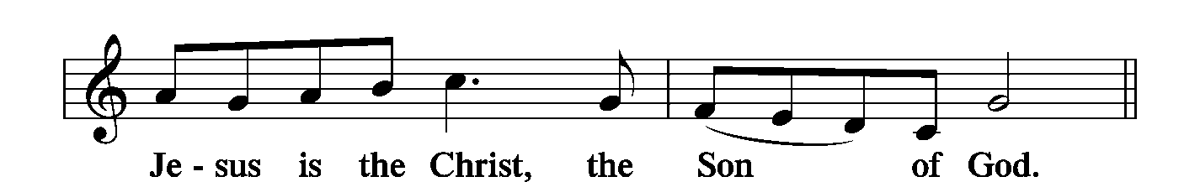
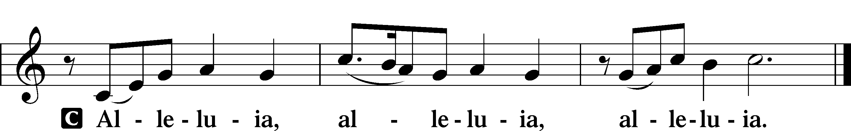

HOLY GOSPEL John 20:19–31
P The Holy Gospel according to St. John, the twentieth chapter.
C Glory to You, O Lord.

¹⁹On the evening of that day, the first day of the week, the doors being locked where the disciples were for fear of the Jews, Jesus came and stood among them and said to them, “Peace be with you.” ²⁰When he had said this, he showed them his hands and his side. Then the disciples were glad when they saw the Lord. ²¹Jesus said to them again, “Peace be with you. As the Father has sent me, even so I am sending you.” ²²And when he had said this, he breathed on them and said to them, “Receive the Holy Spirit. ²³If you forgive the sins of anyone, they are forgiven; if you withhold forgiveness from anyone, it is withheld.”
²⁴Now Thomas, one of the Twelve, called the Twin, was not with them when Jesus came. ²⁵So the other disciples told him, “We have seen the Lord.” But he said to them, “Unless I see in his hands the mark of the nails, and place my finger into the mark of the nails, and place my hand into his side, I will never believe.”
²⁶Eight days later, his disciples were inside again, and Thomas was with them. Although the doors were locked, Jesus came and stood among them and said, “Peace be with you.” ²⁷Then he said to Thomas, “Put your finger here, and see my hands; and put out your hand, and place it in my side. Do not disbelieve, but believe.” ²⁸Thomas answered him, “My Lord and my God!” ²⁹Jesus said to him, “Have you believed because you have seen me? Blessed are those who have not seen and yet have believed.”
³⁰Now Jesus did many other signs in the presence of the disciples, which are not written in this book; ³¹but these are written so that you may believe that Jesus is the Christ, the Son of God, and that by believing you may have life in his name.

P This is the Gospel of the Lord.
C Praise to You, O Christ.

NICENE CREED
C I believe in one God,
the Father Almighty,
maker of heaven and earth
and of all things visible and invisible.

And in one Lord Jesus Christ,
the only-begotten Son of God,
begotten of His Father before all worlds,
God of God, Light of Light,
very God of very God,
begotten, not made,
being of one substance with the Father,
by whom all things were made;
who for us men and for our salvation came down from heaven
and was incarnate by the Holy Spirit of the virgin Mary
and was made man;
and was crucified also for us under Pontius Pilate.
He suffered and was buried.
And the third day He rose again according to the Scriptures
and ascended into heaven
and sits at the right hand of the Father.
And He will come again with glory to judge both the living and the dead,
whose kingdom will have no end.
And I believe in the Holy Spirit,
the Lord and giver of life,
who proceeds from the Father and the Son,
who with the Father and the Son together is worshiped and glorified,
who spoke by the prophets.
And I believe in one holy Christian and apostolic Church,
I acknowledge one Baptism for the remission of sins,
and I look for the resurrection of the dead
and the life T of the world to come. Amen.

Please be seated

“ALL GOD’S CHILDREN” TALK

SERMON HYMN
Crown Him with Many Crowns LSB 525
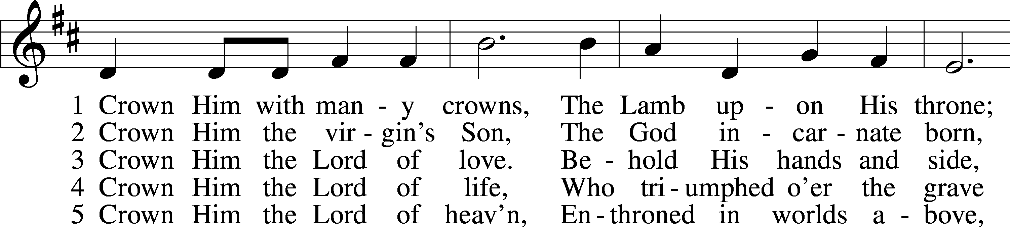
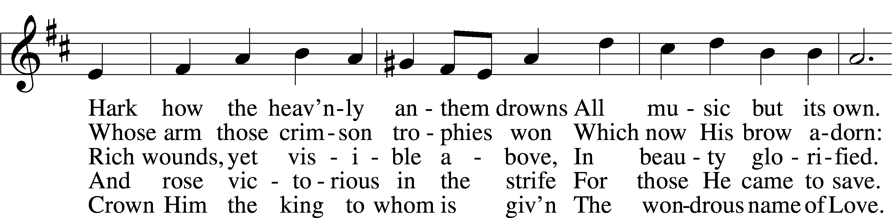
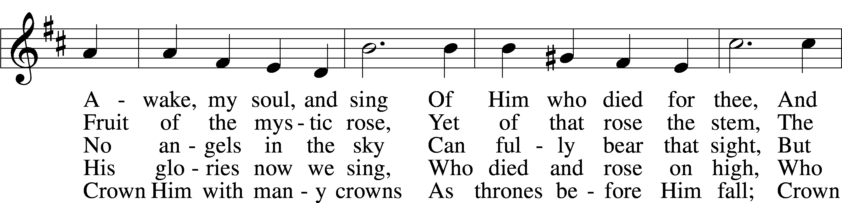
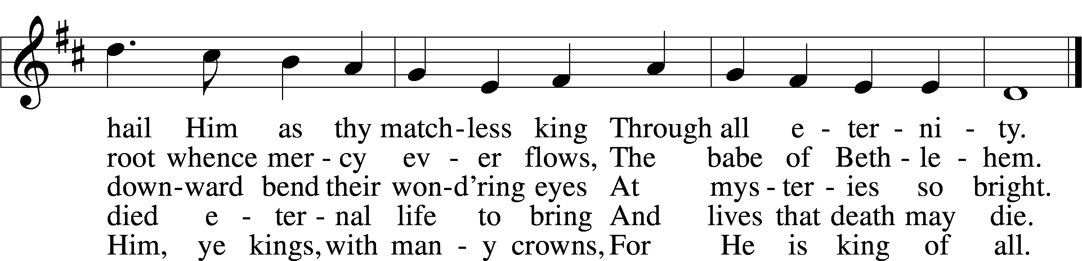
Text (sts. 1–3, 5): Matthew Bridges, 1800–94, alt.; (st. 4): Godfrey Thring, 1823–1903
Tune: George J. Elvey, 1816–93
Text and tune: Public domain

SERMON
Please stand as able

PRAYER of the CHURCH
After each Segment:
P Lord, in Your Mercy,
C Hear our Prayer.
After Final Segment:
P Hear us as we pray in His name and as He has taught us:
LORD’S PRAYER
C Our Father who art in heaven,
hallowed be Thy name,
Thy kingdom come,
Thy will be done on earth
as it is in heaven;
give us this day our daily bread;
and forgive us our trespasses
as we forgive those
who trespass against us;
and lead us not into temptation,
but deliver us from evil.
For Thine is the kingdom
and the power and the glory
forever and ever. Amen.

SERVICE of the SACRAMENT

PREFACE LSB 208
P The Lord be with you.
C And also with you.

P Lift up your hearts.
C We lift them to the Lord.

P Let us give thanks to the Lord our God.
C It is right to give Him thanks and praise.

P It is truly good, right, and salutary that we should at all times and in all places give thanks to You, O Lord, holy Father, almighty and everlasting God, for the countless blessings You
so freely bestow on us and all creation. Above all, we give thanks for Your boundless love shown to us when You sent Your only-begotten Son, Jesus Christ, into our flesh and laid on Him our sin, giving Him into death that we might not die eternally. Because He is now risen from the dead and lives and reigns to all eternity, all who believe in Him will overcome sin and death and will rise again to new life. Therefore with angels and archangels and with all the company of heaven we laud and magnify Your glorious name, evermore praising You and singing;

SANCTUS LSB 208
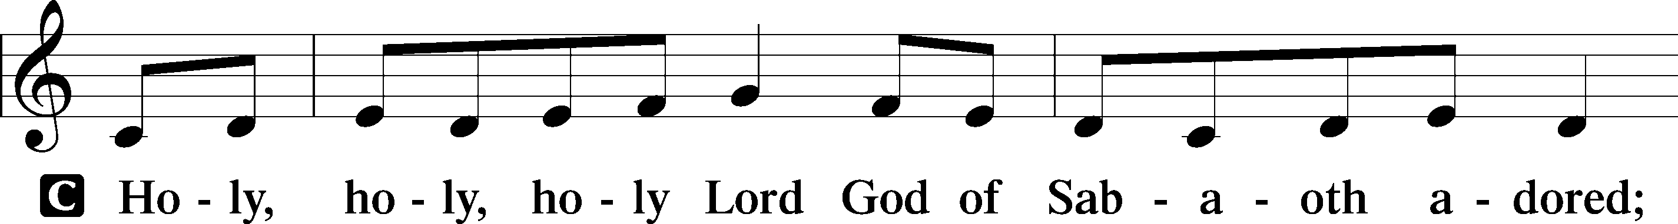
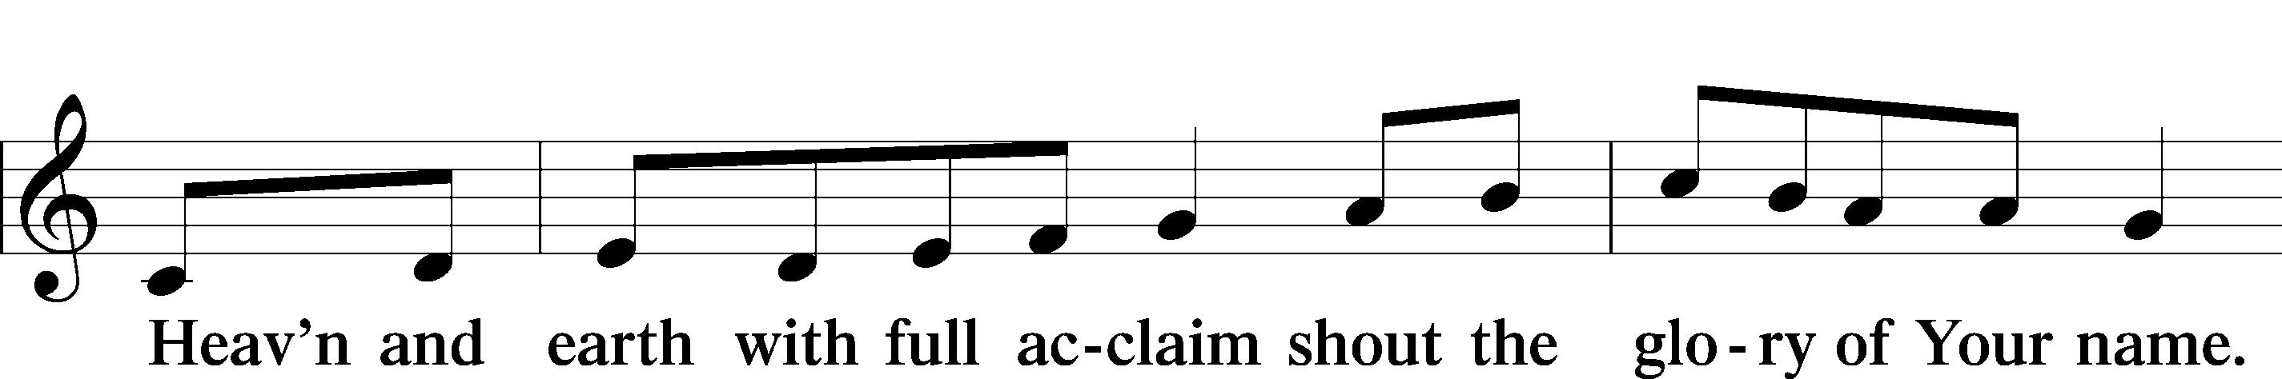
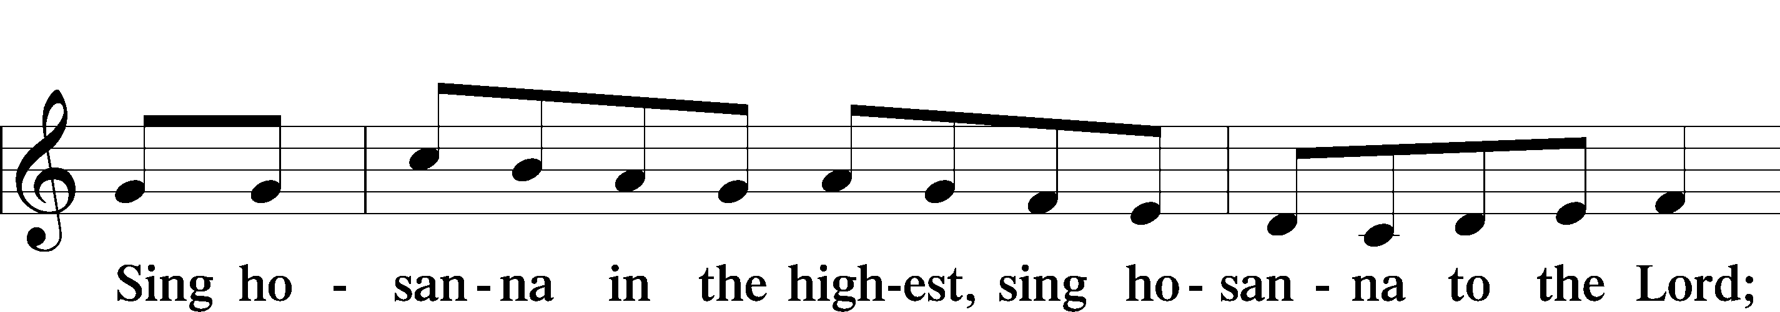

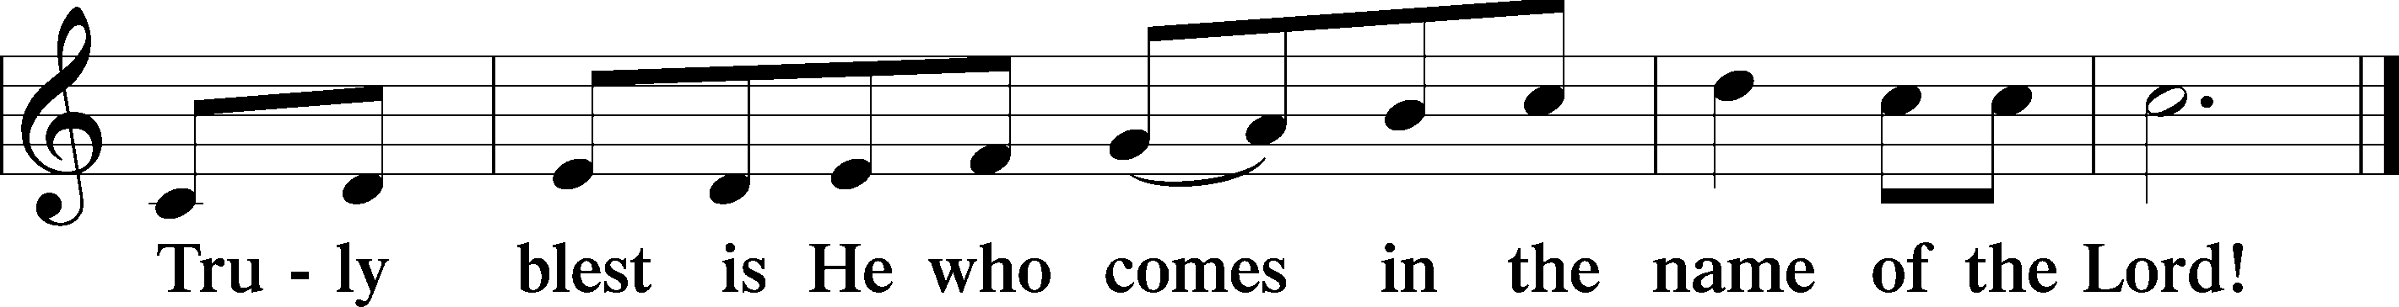

THE WORDS OF OUR LORD
P Our Lord Jesus Christ, on the night when He was betrayed, took bread, and when He had given thanks, He broke it and gave it to the disciples and said: “Take, eat; this is My T body, which is given for you. This do in remembrance of Me.”
In the same way also, He took the cup after supper, and when He had given thanks, He gave it to them, saying: “Drink of it, all of you; this cup is the New Testament in My T blood, which is shed for you for the forgiveness of sins. This do, as often as you drink it, in remembrance of Me.”

PAX DOMINI
P The peace of the Lord be with you always.
C Amen.
AGNUS DEI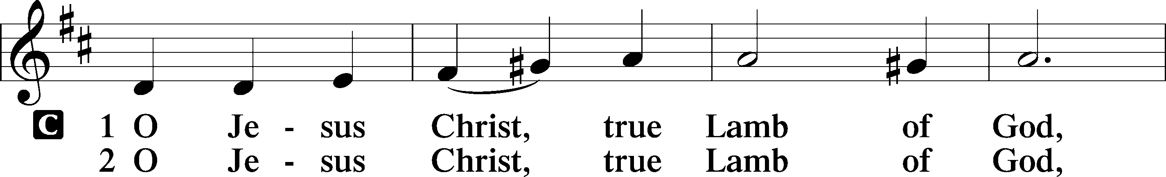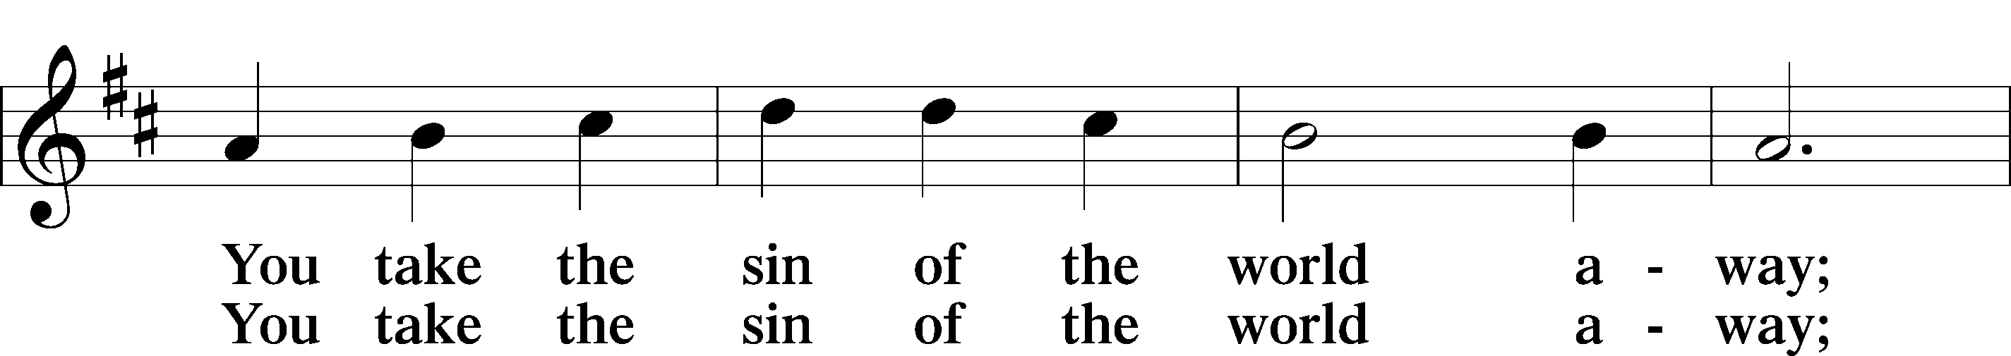
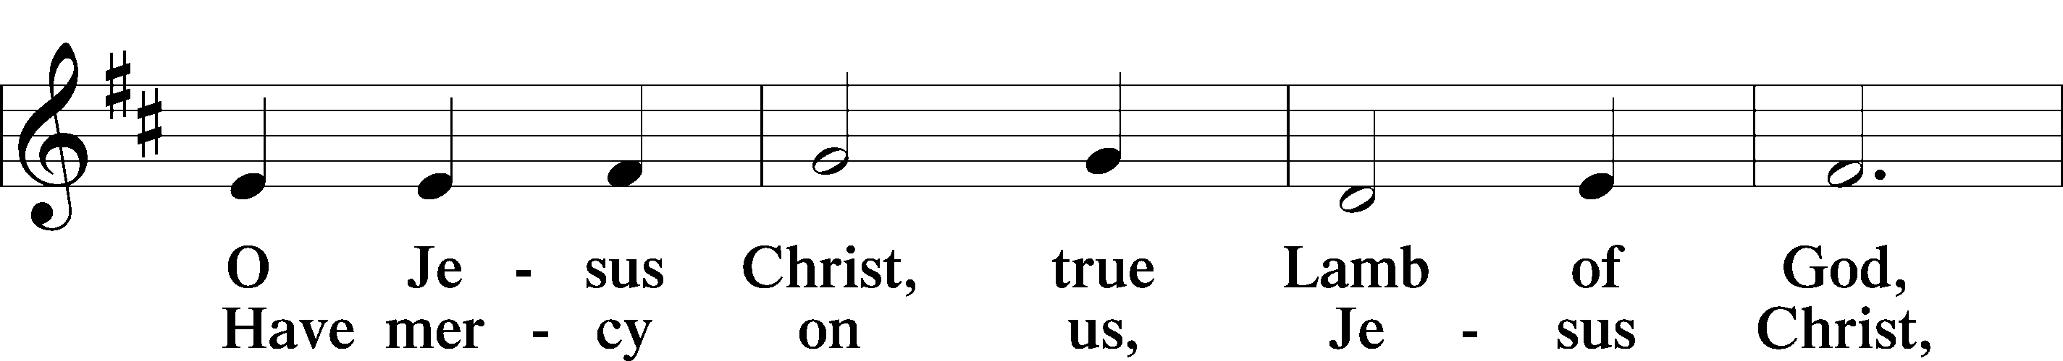
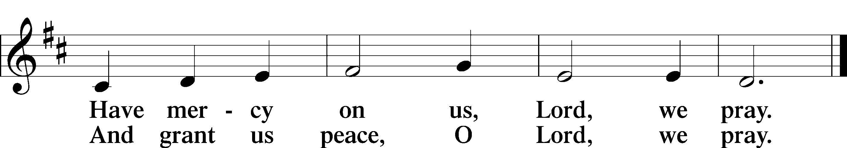

Please be seated

DISTRIBUTION

The pastor and those who assist him receive the body and blood of Christ first, then Communion
will be served in a continuous fashion. Households may commune at the same time together. Ushers will help direct you forward via the center aisle; please return to your seats via the side aisles. Gluten-free bread is available for those who need it, as is non-alcoholic grape juice. Simply request either when you come forward to receive Communion.

All Hail the Power of Jesus’ Name LSB 549
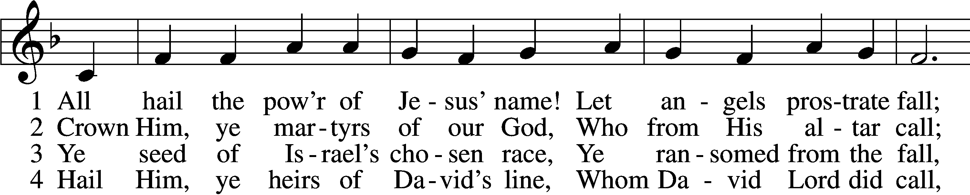
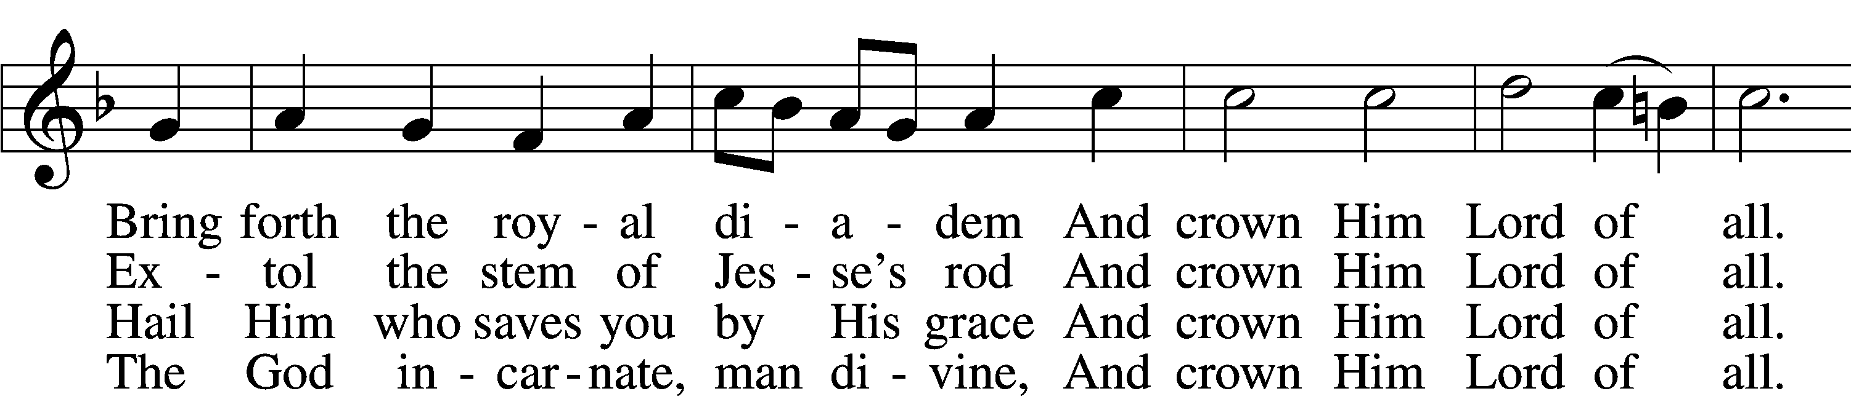
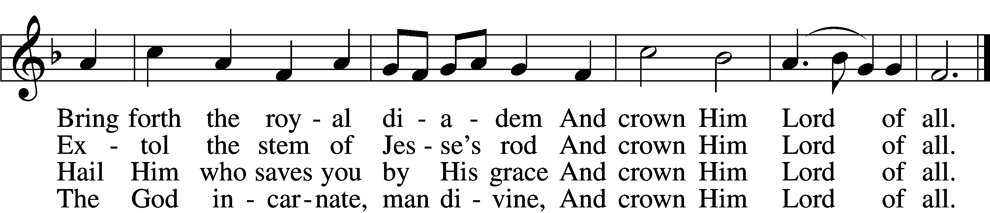

5 Sinners, whose love can ne’er forget
The wormwood and the gall,
Go, spread your trophies at His feet
And crown Him Lord of all.
Go, spread your trophies at His feet
And crown Him Lord of all.

6 Let ev’ry kindred, ev’ry tribe,
On this terrestrial ball
To Him all majesty ascribe
And crown Him Lord of all.
To Him all majesty ascribe
And crown Him Lord of all.

7 Oh, that with yonder sacred throng
We at His feet may fall!
We’ll join the everlasting song
And crown Him Lord of all.
We’ll join the everlasting song
And crown Him Lord of all.
Text (sts. 1–5): Edward Perronet, 1726–92, alt.; (sts. 6–7): A Selection of Hymns, 1787, London, alt.
Tune: Oliver Holden, 1765–1844
Text and tune: Public domain

Please stand as able
THE DISMISSAL
P The body and blood of our Lord Jesus Christ strengthen and preserve you in body and soul
to life everlasting. Depart T in peace.
C Amen.

NUNC DIMITTIS LSB 211
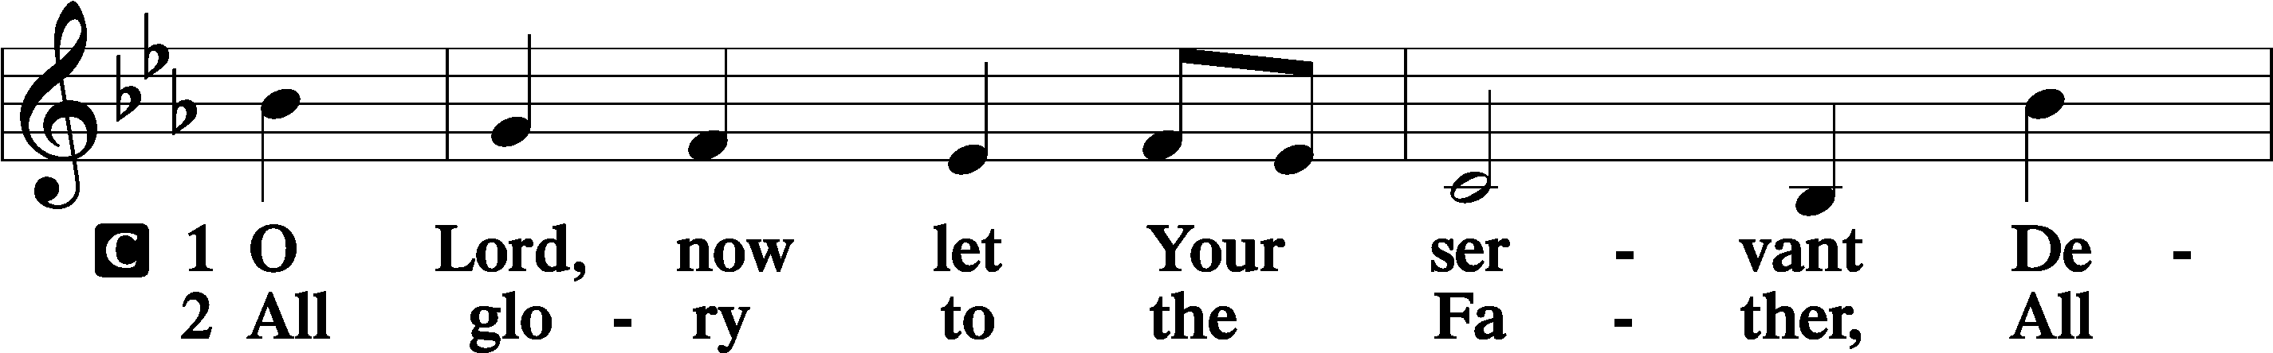
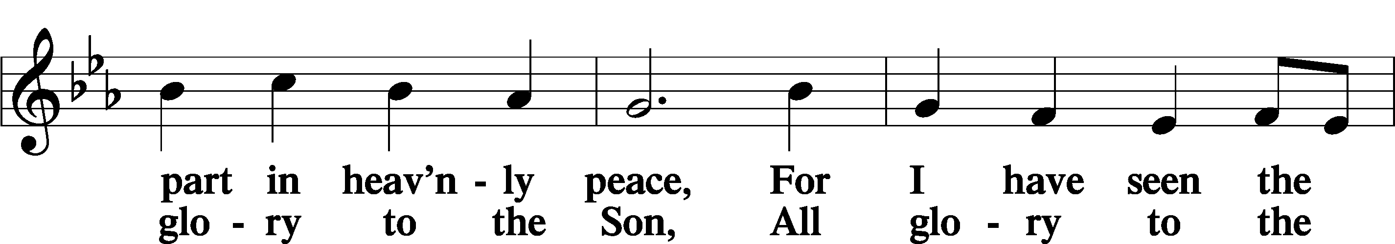
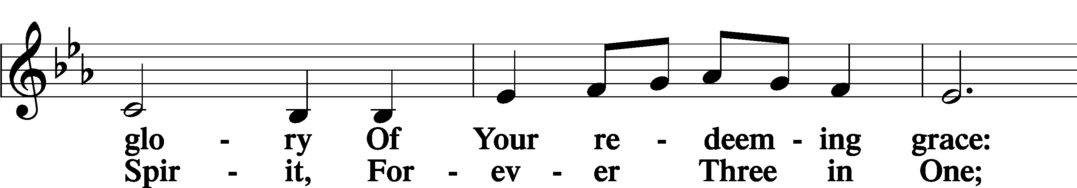
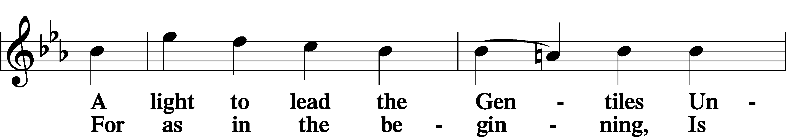
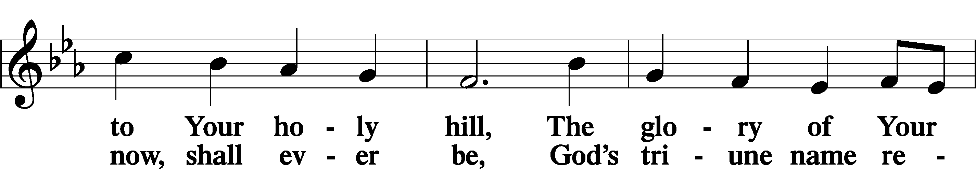
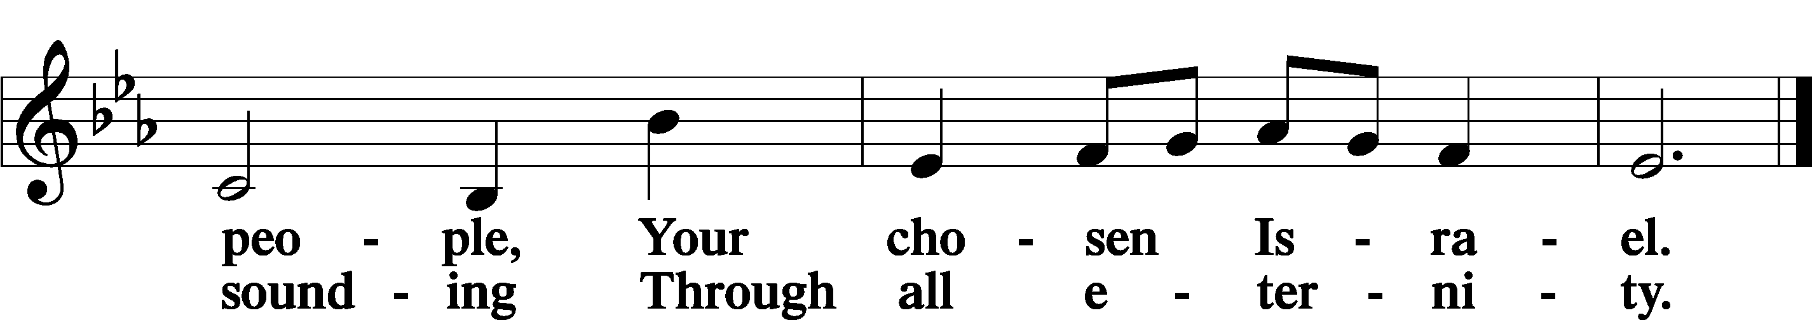

POST COMMUNION COLLECT
P Let us pray.
We give thanks to You, almighty God, that You have refreshed us through this salutary gift, and we implore You that of Your mercy You would strengthen us through the same in faith toward You and in fervent love toward one another; through Jesus Christ, Your Son, our Lord, who lives and reigns with You and the Holy Spirit, one God, now and forever.
C Amen.

BENEDICAMUS LSB 212
P Let us bless the Lord.
C Thanks be to God.
BENEDICTION
P The Lord bless you and keep you.
The Lord make His face shine on you and be gracious to you.
The Lord look upon you with favor and T give you peace.
C Amen.

Please be seated
CLOSING HYMN
Savior, Again to Thy Dear Name We Raise LSB 917
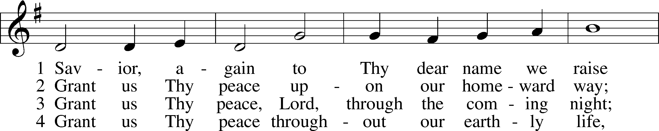
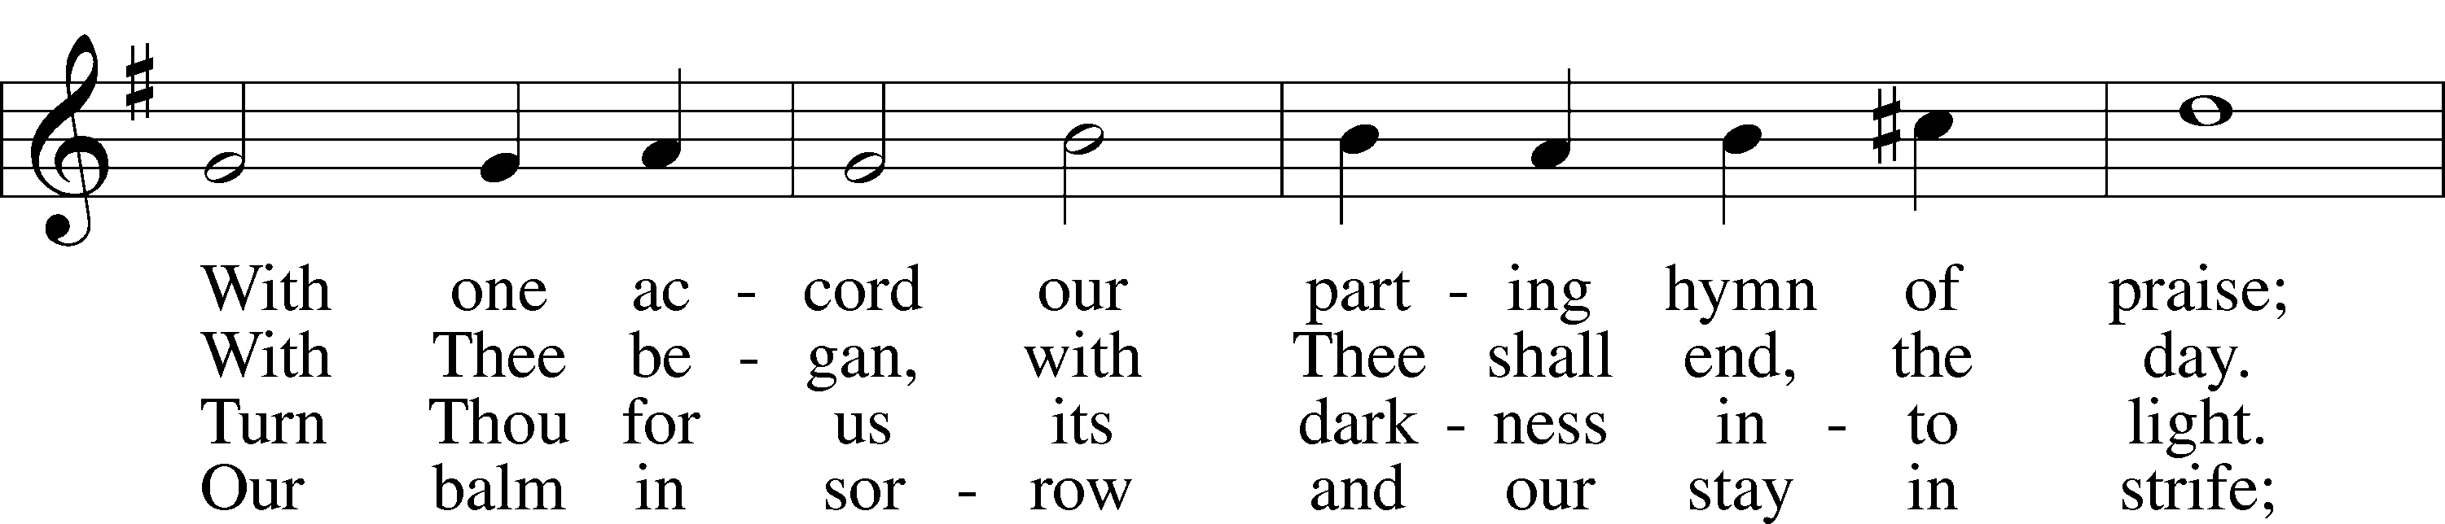
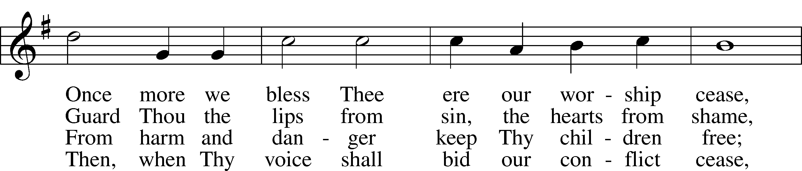
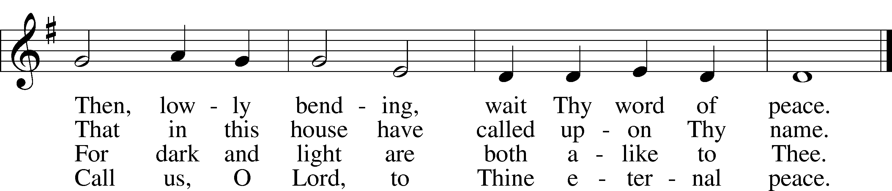
Text: John Ellerton, 1826–93
Tune: Edward J. Hopkins, 1818–1901
Text and tune: Public domain

ANNOUNCEMENTS and SENDING WORDS
P We go to live for Jesus!
C We go to share His love!

Acknowledgments
Unless otherwise indicated, Scripture quotations are from the ESV® Bible (The Holy Bible, English Standard Version®), copyright © 2001 by Crossway, a publishing ministry of Good News Publishers. Used by permission. All rights reserved. Created by Lutheran Service Builder© Concordia Publishing House.

NEXT WEEKS READINGS
Old Testament: Acts 9:1-22
Epistle: Revelation 5: 1-14
Holy Gospel: John 21:1-14 (15-19)

SERVING in GODS HOUSE TODAY
Pastor: Rev. Ken Bernthal
Elder: Ken Mertz
Ushers: Roxy Mohr, Ron Tessolin
Greeters: Ken & Ann Mertz
Coffee: Mertz
Counters: Janet Arner, Sandy Smith
Altar Care: Teri Raithel
Organ/Piano: Tom & Jean Beach
Children’s Talk: Nancy Ely
PRAYERS
Please contact the office with updates to the prayer list. People will remain on the prayer list for 4 weeks before being removed. If they need to remain on the list, please keep Elaine informed and of any updates. This will help us to have a more accurate list. Thanks for your cooperation.

Those who continue to grieve the passing of loved ones, .
Those with upcoming surgery:
Those recovering from surgery: Jennifer Martin, and Ron Kwapis
Those with health concerns: Tiffany Amsdill, Laurie Breen, Hope Buchinger, Karen Christoff, Betsy Cookm Kay Gregg, Hilda Koch, Eleanor Raether, Beth Smith, Judi Stutzman, and Joann Whitney.
Those diagnosed with cancer: Leah Eicher, Maria Freimark, Rachel Frisch, Joe Gibson, Janice Knoellinger, Leslie Martin, Brian Morgan, Hope Osantowski,, Ken Radke, and John Stutzman.
Those under Hospice Home Care: Ruth Luebs, and Ken Williamson.

BIRTHDAYS: ANNIVERSARIES;
4/25 Tina Van Til 4/29 Scott & Lonna Purgaric
4/27 Jon Elenz
4/27 Tim Van Til
4/28 Alison Vezina
4/29 Kay Gregg

MESSAGES

MEMBER & GUEST CARDS: If you have not filled out a member/guest card, please take the time to fill one out and place it in the plate behind the back pews in our sanctuary.

WEDNESDAY MORNING BIBLE STUDY, 10:00am in the fellowship hall with Pastor Ken Bernthal.

NOISY OFFERING: Today we will have a “noisy offering” to benefit the Otsego County Food Pantry. We ask that you consider dropping your pocket change in the buckets thereby helping feed the hungry in our community. All funds collected in these buckets will go to the Otsego County Food Pantry.

CANCER and FRIENDS SUPPORT GROUP: Will be meeting April 26th. We will be having a guest speaker from OCCOA. Please remember Cancer & Friends Support Group is not just for people going through treatment, or survivors, it is also for caregiver, spouse, children, and friends. There are times when we can all use someone to talk to during those difficult times. If there is any subject you would like to discuss with me you call or text or at 989-350-4391. Hope you will join us.

LWML WOMEN FOR CHRIST ELECTION OF OFFICERS is coming up in May. Trinity’s LWML group offices elected this year are Treasurer and Vice President. This takes place in May. If you are interested in running for one of these offices, please let Carla Elenz know, phone 989-390-1305.
LWML SUMMER POP-UP CRAFT SALES: LWML plans to have occasional mini craft sales this summer. With short notice we will set up a few canopies in the front yard and offer our crafts for sale, with the profits designated for missions, both locally and throughout the world. Dates have yet to be determined. So crafters, please get thinking about what handmade items you can prepare in advance for us to sell. We welcome and appreciate your donations.

LWML ZONE RALLY is at Mt. Hope, Grayling on Saturday, May7, 10am. Ann Hume of God’s Children Haiti will be the guest speaker. Ladies, mark the date on your calendars, and watch our church bulletins for further details.

KUT-UPS: Next meeting is Monday April 25th in the fellowship hall.

OTSEGO COUNTY FOOD PANTRY: If you would like to help at the Food Pantry on future dates for which Trinity is responsible for the manpower in distributing food to drive-up customers, there are sign-up sheets on our narthex bulletin board. Our next dares are-
Trinity will be working the pantry on Friday, May 6, from 11:45 a.m. till 2:00 p.m. at the United Way building. The list is on the wall across from the office. Five workers are needed each day. Please sign up.
TEFAP remember that there will be a food giveaway on May 17th at Otsego County United Way parking lot 116 E. First St. from 10am to 1pm.

LWML Celebrate Spring and fellowship with friends with a MYSTERY HOSTESS dinner, sponsored by LWML and the Outreach Committee. What is a Mystery Hostess dinner? We are having a meal at church. You get to choose a meal that you would like, but you don’t know who is preparing your meal until the evening of the event when you join your host/hostess and fellow diners for a delicious meal. There will be a sign up sheet listing the various meals which are available. You pick the one you want and then be prepared to be surprised by your host/hostess. This will be happening Friday, May 13 at 6 PM. Everyone is invited. Each meal/table is limited to 6 persons, so you will have an intimate dining experience. Please sign up for your culinary choice.
Also, if you have a desire to host a table and prepare your specialty, please contact Carla Elenz or Kathy Erat.

Dear Members and Friends of Trinity,

Praise God for Easter Sunday’s joyful worship as we celebrated the resurrection of Christ Jesus our Lord and Savior. He is risen! He is risen, indeed! Alleluia!

We, the Trinity Board of Elders, want to thank the choir and their Director (Dr. Tom Beach) and our trumpeter, Rich Wagner, for their musical contribution in the service. Also, we want to thank the Altar Care for the beautification of the sanctuary. Praise be to God!

We are sending this communication to announce a change concerning the serving of Holy Communion starting on Sunday, May 1, 2022. It has been discussed for several months and finally in April’s Elders’ Meeting it was decided that we should go back to our tradition of serving Communion at the service rails. We based our decision on most restrictions being dropped and that several congregations in our synod have gone back to serving Communion at the rail for many weeks now.

We will continue to serve the alcohol and nonalcoholic individual cups only (no common cup) with the unleavened and gluten-free wafers. Concerning masks, as is the current policy we leave that up to you to decide. Also, if you do have flu-like symptoms, we encourage you to stay home until you are well.

We believe this will draw us closer together as the Body of Christ Jesus.

In His Service,
The Board of Elders

THIS WEEK AT TRINITY
April 24 Sunday
9:00 am Worship Service - Holy Communion – Rev. Ken Bernthal
Noisy Offering
10:00 am Fellowship & Coffee Hour
10:30 am Sunday Morning Bible Study W/ Dr. Tom Beach

April 25 Monday
10:00 am Kut-Ups Fellowship Hall
7:00 pm Choir

April 26 Tuesday
5:30 pm Cancer & Friends Support Group (Fellowship Hall)
5:30 pm Building committee for the new pole barn

April 27 Wednesday
10:00 am Wednesday Morning Bible Study W/ Pastor Ken Bernthal

April 28 Thursday
7:00 pm Erat Home Bible Study Group (Erats)

April 29 Friday

April 30 Saturday

May 1 Sunday
9:00 am Worship Service - Holy Communion – Rev. Paul Schneider
10:00 am Fellowship & Coffee Hour
10:30 am Bible Study with Dr. Tom Beach (Tutoring Room)

